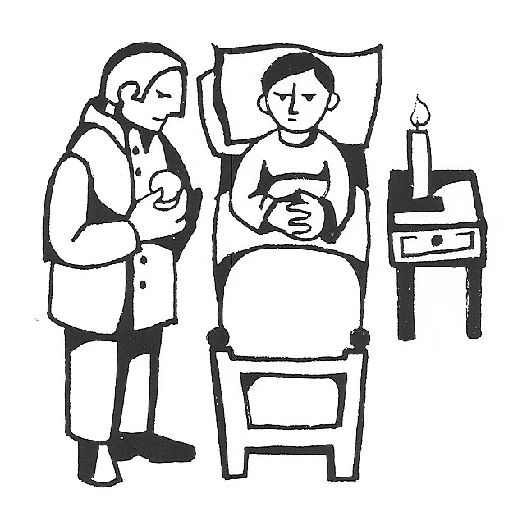
Level II
Training for :

Extraordinary Ministers of Holy Communion
for the sick and homebound

Thursday, May 30, 2019 6:00pm - 9:00pm
Diocesan Chancery Building
303 E South Temple, Salt Lake City
(Corner of “B” Street & South Temple)

Pre-Registration is required - Seating is limited
Please call the Office of Worship to register by:
Tuesday, May 21, 2019
801-328-8641 ext. 357

Registration Fee: $15.00

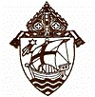

Sponsored by: The Office of Worship Diocese of Salt Lake City

