How To Guide:

Parish/Mission Report Form

The Parish/Mission Report Form is a straightforward way to keep track of and forward gifts to the Catholic Diocese of Salt Lake City. A fillable version of this form can be found at https://www.dioslc.org/images/DDD/documents/Parish-Mission-Report-Form.pdf

Instructions:
Fill out the top part of the form with your name, the date, the parish name, and a phone number in case the finance or development office has any questions.
See Appendix A, entitled “Decision Diagram”, which is a flow chart to guide you through the Parish/Mission Report Form.

Section A: Pledges with Payments
This section is for collections that have a payment, a pledge form and the parishioner wishes to start a monthly or quarterly gift.
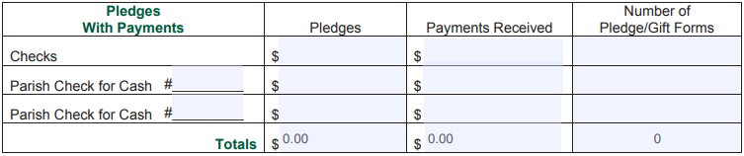
- Checks:
  - “Pledges” column: This is the sum of parishioner pledges for the collection. This is found on the pledge form.
  - “Payments Received” column: This is the sum of the checks that parishioners are gifting for the collection.
  - “Number of Pledge/Gift Forms” column: This is the total amount of pledge forms received for the collection.
- Parish Checks for Cash: This row is for when a parish receives cash from parishioners. Fill out the right side of the cell with the parish check number. DO NOT SEND CASH THROUGH THE MAIL.
  - The columns in this row are filled out the same way the checks row is filled out, except the payments received column will be the total cash received. This should match the dollar amount of the parish check.

Section B: Pledges without Payments
This section is for pledges without checks or cash.
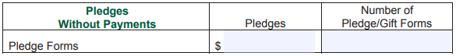
- The “Pledges” column contains the total amount of pledges without payments.
- The “Number of Pledge/Gift Forms” column is the total number of pledge forms received for the collection.

Section C: One-Time Gifts
This section is for one-time gifts that also have a pledge form. When the pledge form’s commitment type is left blank, it is considered a one-time gift.
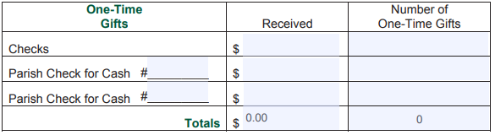
- Checks:
  - “Received” column: This is the sum of the checks that parishioners are gifting for the collection.
  - “Number of One-Time Gifts” column: This is a total count of the number of one-time gift checks received.
- Parish Check for Cash is filled out the same way as the “checks” row. DO NOT SEND CASH THROUGH THE MAIL.

Section D: Loose Checks
This section is for gifts without a pledge form.
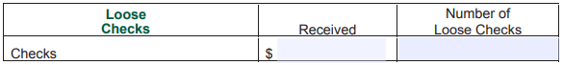
- Add up the dollar amount of checks received for this category and enter it into the “Received” column.
- Add up the number of checks received and enter it into the “Number of Loose Checks” column.

Appendix A: Decision Diagram
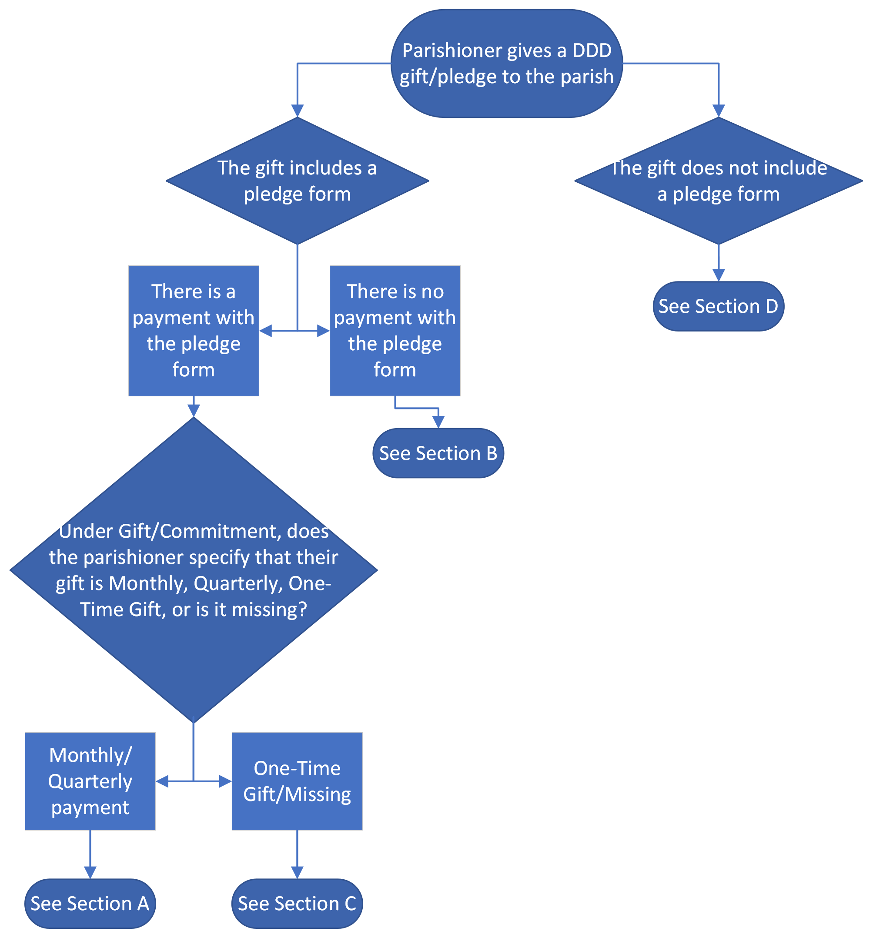

Appendix B: Parish Mission Report Form
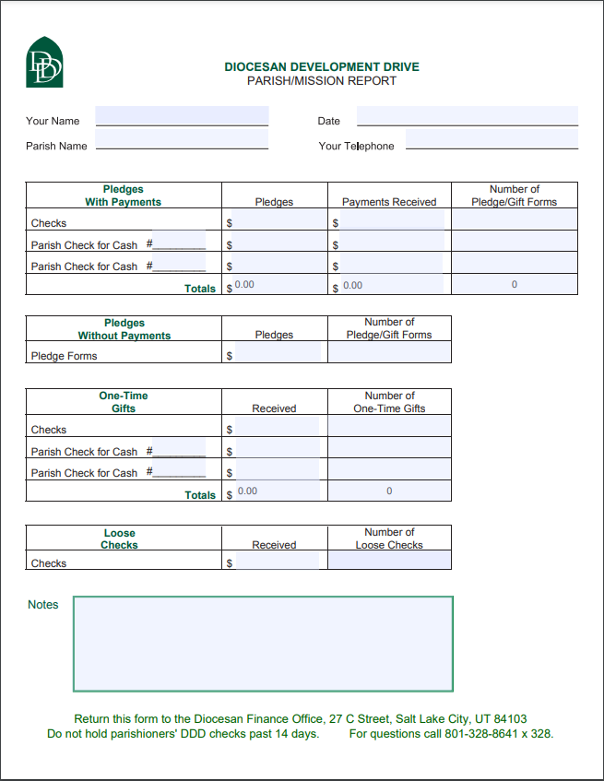

Appendix C: 2024 Pledge Form
